SDLC

MODULE :1

SDLC Software Development Life Cycle Process

SDLC Cycle

SDLC Phases

#1) Requirement Gathering and Analysis

#2) Design

#3) Implementation or Coding

#4) Testing

#5) Deployment

#6) Maintenance

Software Development Life Cycle Models

#1) Waterfall Model

#2) V-Shaped Model

#3) Prototype Model

#4) Spiral Model

#5) Iterative Incremental Model

#6) Big Bang Model

#7) Agile Model

ś

1) what is software?

Software is a set of instructions, data or programs used to operate computers and execute specific tasks.

It is the opposite of hardware, which describes the physical aspects of a computer.

Software is a generic term used to refer to applications, scripts and programs that run on a device.

It can be thought of as the variable part of a computer, while hardware is the invariable part.

2) Types ofsoftware

The two main categories of software are application software and system software.

An application is software that fulfills a specific need or performs tasks.

System software is designed to run a computer's hardware and provides a platform for applications to run on top of.

types of softwares.

1)application software

2)system software.

What is the difference between Application software and system software?

System software runs when the system is turned on and stop when the system is turned off.

While application software runs as per the user's request.

Example: System software is operating system, etc. Example: Application software are Photoshop, VLC player

3) What is Software Development Methodology?

An Introduction To Software Development Methodologies.

There are numerous ways to organise the process of developing and writing code.

Although it is impossible to mandate one way as the only path, there is a great deal to learn from each one.

Learn about the benefits to working in different formats and procedural approaches in this overview on code-creation techniques.

Software development methodology is a process or series of processes used in software development.

Again, quite broad but that it is things like a design phase, a development phase. It is ways of thinking about things like waterfall being a non iterative kind of process.

Generally it takes the form of defined phases. It is designed to describe the how of the life cycle of a piece of software.

It is also codified communication. So you’re actually setting a set of norms between a group of people that say this is how you’re going to work and this is how you’re going to pass information between each of you in certain ways; whether that is documentation, whether that is discussion, whether that is drawings on paper.

Online Shopping System Data Flow Diagram (DFD)

A thorough explanation is provided for the example data flow diagram for online shopping system. This example emphasizes the three DFD levels (DFD Levels 0, 1, and 2).

DFD Level 0 Online Shopping System

The context diagram is an alternative name for the Level 0 DFD Diagram for Online Shopping System. Users, the main process, and data flow make up its parts. Also, the project concept is demonstrated using the single process visualization.

DFD Level 0 shows the entities that interact with a system and defines the border between the system and its environment. This diagram also depicts the online shopping system at a high level.

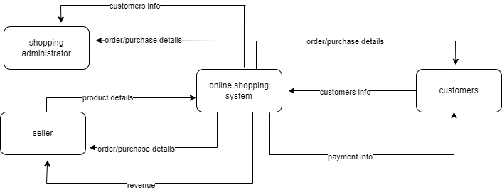

DFD for Online Shopping System Level 0

The illustration presents the main process in a single node to introduce the project context. This context explains how the project works in just one look. The user feeds data into the system and then receives the output from it.

In addition to this, you will perceive through the diagram that there is already the presence of data flow. Though the process is very general, the flow of data is clear. Nevertheless, just modify this diagram to meet the other requirements and include other matters regarding shopping management.

Level 1 DFD for Online Shopping System

The "detonated view" of the context diagram is Online Shopping System DFD Level 1. Its function is to deepen the concept derive from the context diagram.Specifically, level 1 shows the broader details of Online Shopping System DFD Level 0. This is to clarify the paths (flow) of data and its transformation from input to output.

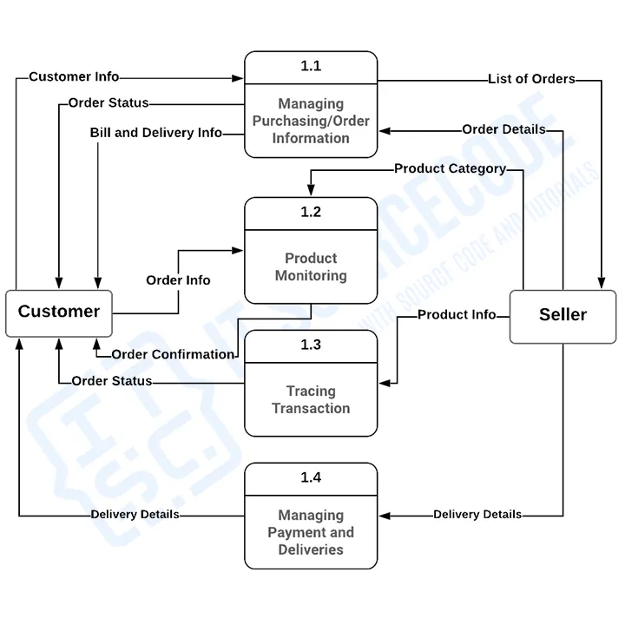 DFD Online Shopping System Level 1

The designed diagram portrays four different scenarios: customer information management, order or reservation management, scheduling of deliveries, and transaction and payments management.

Firstly, the flow of data starts from the restaurant admin or owners and customers. Then the system caters to the transaction. This idea was based on online shopping processes or transactions.

You can also see the data store used or the database. The database is also used in storing users' data inputs. Then it serves as the source of outputs.

Level 2 DFD for Online Shopping System

Level 2 DFD for Online Shopping System is also the highest abstraction of the data flow diagram. This level also broadens the idea from the DFD level 1. It includes the sub-processes from level 1 as well as the data that flows.

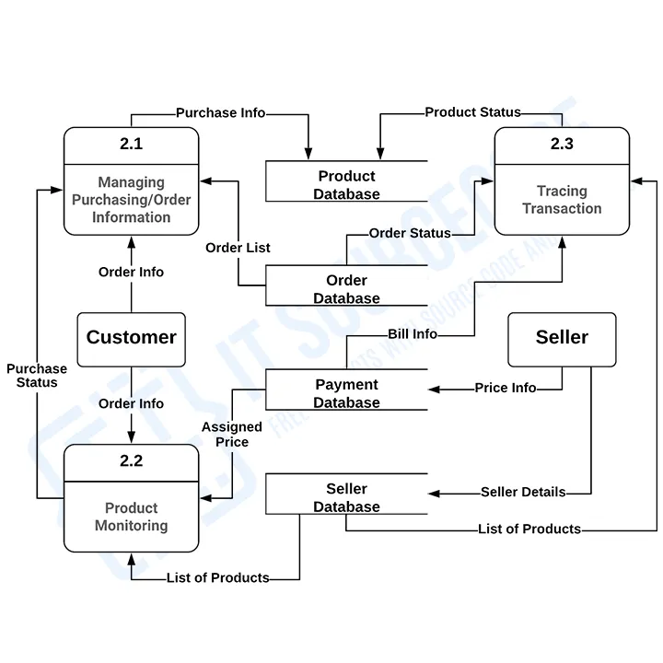

DFD for Online shopping System Level 2

However, not all of the processes in the project must have sub-processes. Only provide this diagram if needed. As long as your previous diagrams were clear and precise, this level is not required.

You can add more to this and it is up to you how will you create your data flow diagram. Also, consider the data flow included and be precise with your information.